ECEN 461 Final Project

Mind Controlled wheelchair

Luke Bird

Evan Hardester

David Turner

Objective:

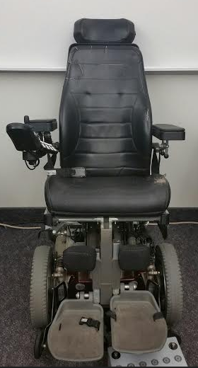 Modify an electric wheelchair to control the motors based off mental commands using an EPOC+ EEG headset. Do this in a way that can be easily adapted to any electric wheelchair (See Figure 1). This has the potential to assist quadriplegics, individuals with spinal muscular dystrophy, and others. We got some of our inspiration from http://www.instructables.com/id/Brain-Controlled-Wheelchair/?ALLSTEPS.

Procedure:

* Obtain materials: electric wheelchair (talk to Brother Grimmett), EPOC+ (talk to Brother Eckersell), Arduino with motor shield, servos, necessary software (EEG SDK, Arduino platform), and necessary screws, shafts, nuts, etc.

Figure 1: Permobil C300 Electric Wheelchair

* Become familiar with all the equipment: how it’s used, how to run code, etc. (See figures 2 and 3)
* 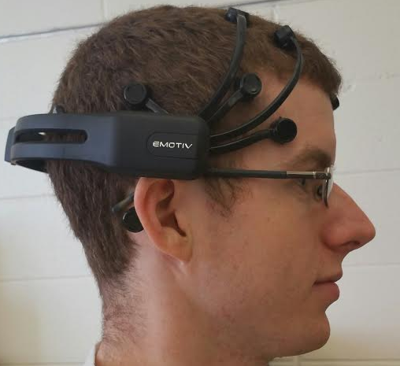Program Arduino to move servos to specific locations depending on what keyboard key is being pressed. Code is found in the appendix. To get this to work we also used Puzzlebox Brainstorms. The python background script is found at <https://puzzlebox.io/brainstorms/development/browser/trunk/Puzzlebox/Brainstorms/Wheelchair_Control.py> and can be run independently, but we used the Puzzlebox Brainstorms program. This script waits for keypresses which correspond to a direction of movement for the wheelchair (i: forward; k&m: reverse; j: left; l: right; space: stop). When one of the defined keypresses is recognized, data is sent to an Arduino connected to the computer which determines how the servos will move.

Figure 2: EPOC placement

* Program the EPOC+ to send key presses depending on which direction is being thought about. This keypress is captured by the Puzzlebox software and sends data to the Arduino. The Arduino then reads the data and moves the servos. The codefor the Arduino is found at https://github.com/southernspud24/MindControlledWheelchair/blob/master/WheelChairFinal.ino
* Mount the servos on the joystick of the wheelchair, one to control forward/backward, and the other to control left/right. (See figure 4) Some tuning may need to be done in the Arduino code to make sure the servos move the joystick to the correct positions.
* Train the user to use the EPOC software to mentally control the virtual cube. Run the Arduino code, plug in the motors, and have fun.

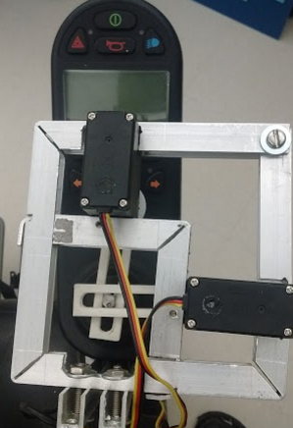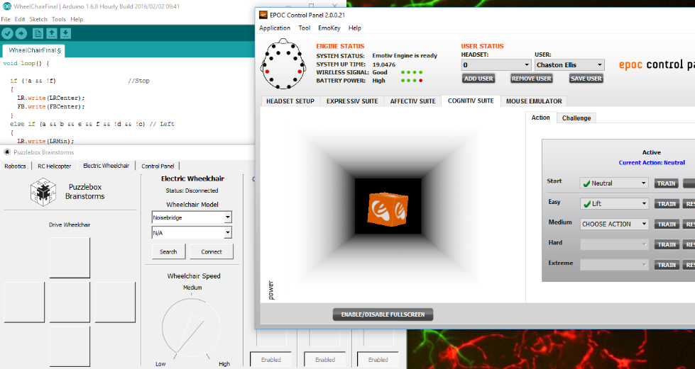

Figure 3: Programs for use of Brain Controlled Wheelchair system.

Figure 4: Motors mounted on the joystick

Note: These are the finalized procedures. At first we tried to make our own EEG headset by soldering pennies onto wires and using the data they collected from the scalp as input to an Arduino. We attempted to use digital filters and amplifiers to make the data usable, but we were unable to get it precise enough. If someone wanted to attempt this approach, they would need to create some filters, bias and amplify the signal so that the Arduino or whichever board is used can get a clear signal. We also tried to take apart the wheelchair control system in the hopes of communicating electronically with the motors. Since the wheelchair utilizes an inductive joystick, this would have been difficult; requiring the use of multiple oscilloscopes and determining the bit values on each line of input. We determined that the chair worked through serial communication, so we would need to watch the data line, along with the clock and chip enable to find out what data we would need to send with the Arduino to simulate joystick movement. Instead, we decided to mount motors on the joystick to control it externally. This method was less invasive to the chair and is a more universal solution that can easily be applied to all electric wheelchairs.

Conclusion:

We were successful in controlling the wheelchair with our minds through the EPOC+. However, when all four directions were utilized the control was a little finicky. Longer training time for the user and a better EEG headset would help with this. Also, since a maximum of four keypresses could be communicated from the EPOC+, we were only able to stop with the use of a timer. In the future we hope to make our own headset and send more than 4 commands. We also wish to communicate directly from the headset to the Arduino to eliminate the need for a laptop during use. Another variation will be to control the wheelchair remotely via Bluetooth. Talk to BYUI’s biomedical engineering society for details.